System and Software Architecture Description (SSAD)

CRCD Management System

Team 11

Muzzammil Imam - Project Manager
Fan Xu - Tester
Jason Loewy - Implementer
Adarsh Khare - Trainer
Kathleen Barrera - Integrated Independent Verification & Validation

04/27/2012

Version History
Date | Author | Version | Changes made | Rationale
10/11/11 | Muzzammil, Fan & Erik | 1.0 | - Section 1, 2.1.1 – 2.1.3 were completed | - Initial draft of SSAD Document
10/12/11 | Erik | 1.1 | - Spellcheck, header/footer adjustments | - Polish
10/19/11 | Muzzammil & Fan | 2.0 | - Diagrams update, removed problems | - Took care of TA comments
10/24/11 | Muzzammil & Fan | 3.0 | - Diagrams updated, use cases updated | - Changes made according to TA comments during ARB
11/21/11 | Muzzammil & Fan | 4.0 | - Diagrams updated and new section added | - New Sections added
12/4/11 | Muzzammil & Fan | 5.0 | - Updates and fixes | - Feedback form DCR
12/10/11 | Muzzammil | 5.1 | - Changes according to feedback | - Feedback from Daniela
02/06/12 | Muzzammil | 6.0 | - Change Impacts due to changed requirements | - Requirements changed during Re-baselining
02/15/12 | Muzzammil | 6.1 | - Changes in Evaluation summary | - Suggestions in ARB
03/25/12 | Muzzammil | 7.0 | - All the minor problems fixed | - Changes made according to TA
04/27/12 | Muzzammil | 8.0 | - Use cases revised | - Changes mad according to code review.

Table of Contents
System and Software Architecture Description (SSAD) i
Version History ii
Table of Contents iii
Table of Tables iv
Table of Figures vi
1. Introduction 1
1.1 Purpose of the SSAD 1
1.2 Status of the SSAD 1
2. System Analysis 2
2.1 System Analysis Overview 2
3. NDI/NCS Interoperability Analysis 21
3.1 Introduction 21
3.2 System Structure 23
3.3 Evaluation Summary 25

Table of Tables
Table 1: Actors Summary 4
Table 2: Artifacts and Information Summary 5
Table 3: Process Description - Login 7
Table 4: Typical Course of Action Login : Successful 7
Table 5: Alternate Course of Action Login : Failure 7
Table 6: Process Description - Logout 8
Table 7: Typical Course of Action Logout : Successful 8
Table 8: Alternate Course of Action Logout : Session expires 8
Table 9: Process Description – Generate Reports 9
Table 10: Typical Course of Action: Generate reports 9
Table 11: Alternate Course of Action Generate reports : Failure 9
Table 12: Process Description – Modify Report Format 10
Table 13: Typical Course of Action: Modify report format 10
Table 14: Alternate Course of Action Modify report format : Failure 10
Table 15: Process Description – Timesheet Approval 11
Table 16: Typical Course of Action: Timesheet approval 11
Table 17: Alternate Course of Action Timesheet change 11
Table 18: Process Description – Timesheet review and submission 12
Table 19: Typical Course of Action: Timesheet review and submission 12
Table 20: Alternate Course of Action Timesheet submission: Failure 13
Table 21: Typical Course of Action: Timesheet review and submission 13
Table 22: Alternate Course of Action Timesheet submission: Failure 14
Table 23: Process Description – Update Inventory Error! Bookmark not defined.
Table 24: Typical Course of Action: Update Inventory Error! Bookmark not defined.
Table 25: Process Description – Update Inventory 14
Table 26: Typical Course of Action: Update Inventory 14
Table 27: Process Description – Employee Admin 15
Table 28: Typical Course of Action: Employee Admin 15
Table 29: Process Description – Employee Admin 15
Table 30: Typical Course of Action: Employee Admin 16
Table 31: Process Description – Employee Admin 16
Table 32: Typical Course of Action: Employee Admin 16
Table 33: Process Description – Employee Admin 17
Table 34: Typical Course of Action: Employee Admin 17
Table 35: Process Description - Payroll Admin 17
Table 36: Typical Course of Action: Payroll Admin 17
Table 37: Process Description - Payroll Admin 18
Table 38: Typical Course of Action: Payroll Admin 18
Table 39: Process Description - Payroll Admin 18
Table 40: Typical Course of Action: Payroll Admin 19
Table 41: Process Description - Payroll Admin 19
Table 42: Typical Course of Action: Payroll Admin 19
Table 43: Process Description - Payroll Admin 20
Table 44: Typical Course of Action: Payroll Admin 20
Table 45: NDI Products Listing 21

Table of Figures
Figure 1: System Context Diagram 3
Figure 2: Artifacts and Information Diagram 5
Figure 3: Process Diagram 6
Figure 4: Deployment Diagram 23
Figure 5: Hardware Configuration 24
Figure 6: Hardware Configuration 25

Introduction

Purpose of the SSAD
This document captures the principal design decisions made for the CRCD Management System (CMS) during all the phases of the development lifecycle. It will be a reference document for the developers of the system so they can implement all the structural elements found in the architecture. This way the system will remain faithful to the architecture, making it easier for the stakeholders to understand the system and know how it functions. Also, it will help the maintainers manage the system easily and consistently.

Status of the SSAD
The current version of the SSAD is version 6.1 and is part of the Rebaselined Development Commitment Package (RDC). The document provides an overview of the CRCD Management System (CMS), describes its context, describes artifacts and information created by the CMS, and describes the behavior of this system.

System Analysis

System Analysis Overview
The primary purpose of the CRCD Management System is to submit employee time cards electronically and allow managers to approve them before they are sent to the payroll administrator. Additionally, there will be a web-based Resource Tracking System within this system, so employees can check in/out inventory items and mangers can track the inventory. The system generates reports based on the needs of managers in a format that will be easy use. This will replace paper time cards and paper sign-out sheets. By automating and tracking this process, there will be fewer errors and by capturing this data, managers will be able to reduce waste and plan more efficiently.

System Context
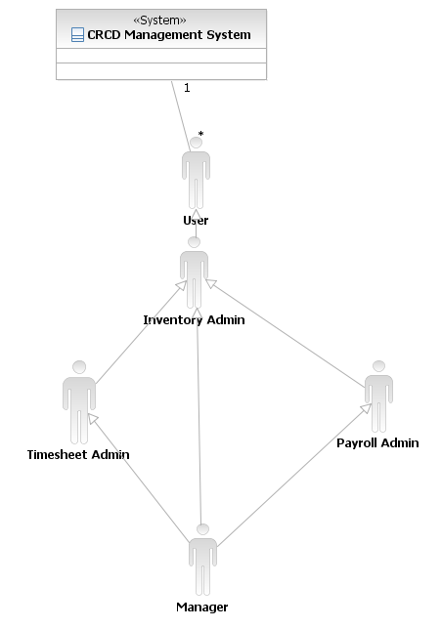

Figure 1: System Context Diagram

Table 1: Actors Summary
Actor | Description | Responsibilities
User | Every person which has access to the system and can login and logout of the system | - Login  - Logout
Manager | A member of the managerial/executive staff of CRCD. (Primary user of the system) | - Reviews employee’s performance  - Approves employee timesheets  - Keeps track of employee’s growth  - Generates reports as needed.  - Modifies reports  - Checks-in and checks-out inventory
Timesheet admin | A member of the staff who is assigned this role to maintain the timesheet system. | - Adds employee  - Delete Employee if needed  - Update Employee information
Inventory admin | A member of the staff who is assigned this role to maintain the inventory system. | - Adds products  - Delete products if needed  - Update product quantity
Payroll admin | HR employee who reviews timesheets for final submission and then submits it to the ADP system. | - Enters timesheets  - Updates timesheets  - Reviews timesheets  - Sends it to ADP Payroll system  - Accesses ADP Payroll system
ADP Payroll System | Interface that connects the Timesheet system with the ADP Payroll system | - Allows the Timesheet system to submit

Artifacts & Information

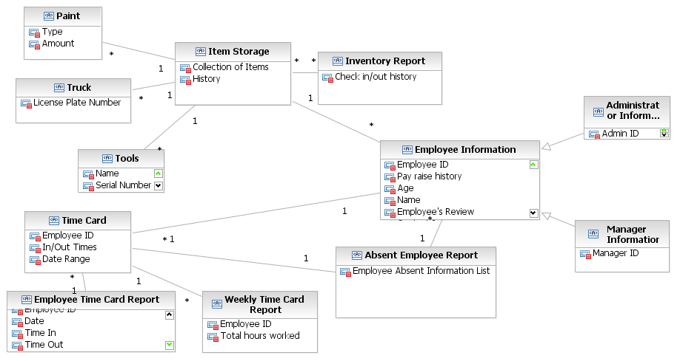

Figure 2: Artifacts and Information Diagram

Table 2: Artifacts and Information Summary
Artifact | Purpose
Tools | An artifact that contains tools information.
Trucks | An artifact that contains truck information.
Paint | An artifact that contains paint information.
Item Storage Information | An artifact that contains items storage information.
Inventory Report | A report contains inventory checking history generated by managers.
Time card | Contains a series of time In/Out information over a time period.
Employee Time Card Report | Report contains time card information for an employee
Absent Employee Report | Time card report for absent employees
Weekly Time Card summary | Weekly time card summary submitted to ADP system
Employee Information | Contains employee data
Administrator Information | Contains administrator’s data
Manager Information | Contains manager’s data

Behavior
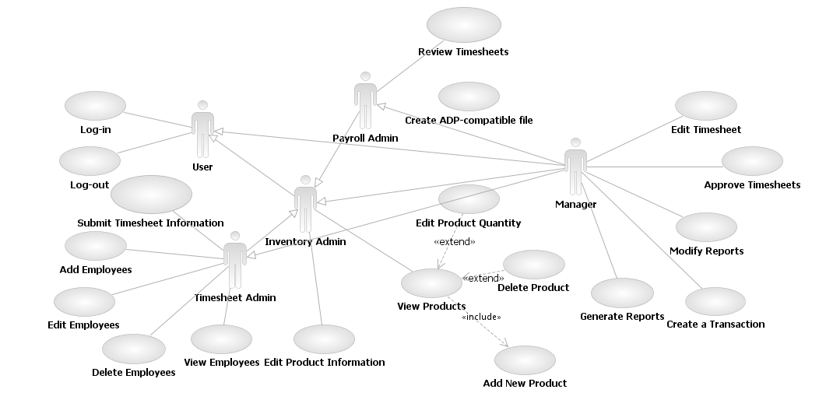
Figure 3: Process Diagram

Authentication

Login
Table 3: Process Description - Login
Identifier | UC-1: Login
Purpose | Authorize a user to log into the system and determine the users  role(s) and access privileges.
Requirements | WC_321-- Only Managerial (Administrator) access to the data
Development Risks | None
Pre-conditions | System Database has been properly initialized.
Post-conditions | • If the user’s log in information is authorized, the user is able  to access system within the specifications of the user’s role  • If the user’s log in information is not authorized, the system  tells the user he has entered an invalid username and password

Table 4: Typical Course of Action Login : Successful
Seq# | Actor’s Action | System’s Response
1 | Enter username and password andClick the “Login” button
2 |  | Validate username and password
3 |  | Redirect the user to their home page.
Table 5: Alternate Course of Action Login : Failure
Seq# | Actor’s Action | System’s Response
1 | Enter a username and password and Click the “Login” button
2 |  | Check username and password
3 |  | Return the user to the log in page and  notifies the user that he has entered an  invalid username or password

Logout
Table 6: Process Description - Logout
Identifier | UC-2: Logout
Purpose | Log a user out of the system
Requirements | WC_321-- Only Managerial (Administrator) access to the data
Development Risks | None
Pre-conditions | • The user is logged into the system  • The user’s session exists
Post-conditions | • The user is logged out of the system and session is terminated

Table 7: Typical Course of Action Logout : Successful
Seq# | Actor’s Action | System’s Response
1 | Click the “log out” link
2 |  | Log the user out of the system and  terminate the session
3 |  | Validate username and password
4 |  | Notify the user that he has logged out of  the system

Table 8: Alternate Course of Action Logout : Session expires
Seq# | Actor’s Action | System’s Response
1 | Log into the system for the  amount of minutes before the  session expires.
2 |  | Log the user out of the system and  terminate the session.
3 |  | Notify the user that the session has  expired and that he has been logged out  of the system

Reports

Generate Report
Table 9: Process Description – Generate Reports
Identifier | UC-3 Generate Reports
Purpose | Give managers the opportunity to generate reports for timesheets and inventory
Requirements | WC_299--  Track inventory as employees check them in and outeach day. Track who checked them out, and the amount of materials consumed.
Development Risks | None
Pre-conditions | User is a manager  User is logged into the system  Database is initialized
Post-conditions | The system is able to generate reports based on the criteria given on the format specified.

Table 10: Typical Course of Action: Generate reports
Seq# | Actor’s Action | System’s Response
 | Select the category, Input the criteria, Click Generate Reports button
 |  | Validate criteria
 |  | Check the database for matching records
 |  | Display the generated report in the correct format to the user
Table 11: Alternate Course of Action Generate reports : Failure
Seq# | Actor’s Action | System’s Response
 | Select the category, Input the criteria and Click Generate Reports button
 |  | Validate criteria
 |  | Reload the page and indicate that required field were incomplete or invalid

Modify Report Format
Table 12: Process Description – Modify Report Format
Identifier | UC-4 Modify Reports
Purpose | Give managers the opportunity to modify report formats
Requirements | WC_299-- Track inventory as employees check them in and outeach day. Track who checked them out, and the amount of materials consumed.
Development Risks | None
Pre-conditions | User is a manager  User is logged into the system  Database is initialized
Post-conditions | The system is able to change the outlook of the report as specified by the user

Table 13: Typical Course of Action: Modify report format
Seq# | Actor’s Action | System’s Response
 | Select the category, Change the format options like fonts and sizes, Click Modify Report button
 |  | Validate new format
 |  | Check the database for matching records
 |  | Display the modified format
Table 14: Alternate Course of Action Modify report format : Failure
Seq# | Actor’s Action | System’s Response
 | Select the category, Change the format options like fonts and sizes and Click Modify Report button
 |  | Validate new format
 |  | Reload the page and indicate the invalid input in the format fields causing failure.

Timesheet Management

Weekly Timesheet Approval
Table 15: Process Description – Timesheet Approval

Identifier | UC-5 Approve Timesheets
Purpose | Give managers the opportunity to approve weekly timesheets for their subordinates.
Requirements | WC_291--Interface: must pass the payroll data to ADP for payroll processing
Development Risks | None
Pre-conditions | User is a manager  User is logged into the system  Database is initialized
Post-conditions | The system is able to change the status of the report to approve and send a copy of it to the administrator through email.

Table 16: Typical Course of Action: Timesheet approval
Seq# | Actor’s Action | System’s Response
 | Select the employee, Click “Approve”
 |  | Give approval confirmation on the screen
 | Click “Send it to Payroll admin”
 |  | Update the database.
 |  | Make the report visible to Payroll admin
 |  | Give transfer confirmation on the screen
Table 17: Alternate Course of Action Timesheet change
Seq# | Actor’s Action | System’s Response
 | Select the employee, Click “Change time”, Change the time entries and Click “Approve”
 |  | Give approval confirmation on the payroll’s admin screen
 | Click “Send it to Payroll admin”
 |  | Update the database.
 |  | Make the report visible to Payroll admin
 |  | Give transfer confirmation on the screen

Timesheet review and Submission
Table 18: Process Description – Timesheet review and submission
Identifier | UC-6 Create ADP-compatible file
Purpose | Payroll admin can submit the timesheet to the current ADP system
Requirements | WC_291--  Interface: must pass the payroll data to ADP for payroll processing
Development Risks | ADP Payroll system interface compatibility with TimeTrex system unknown.
Pre-conditions | User is a payroll admin  User is logged into the system  Database is initialized  Timesheet is approved and sent by the manager
Post-conditions | Timeheet system creates a file in ADP format

Table 19: Typical Course of Action: Timesheet review and submission
Seq# | Actor’s Action | System’s Response
 | Select the timesheet, Make entries needed by the ADP system, Click save entries
 |  | Validate entries
 |  | Give Saving confirmation on the screen
 |  | Update the database.
 | Click “Save as ADP format”
 |  | Create ADP formatted file in default directory

Table 20: Alternate Course of Action Timesheet submission: Failure
Seq# | Actor’s Action | System’s Response
 | Select the timesheet, Make entries needed by the ADP system, Click save entries
 |  | Validate entries
 |  | Give Saving confirmation on the screen
 |  | Update the database.
 | Click “Send it to ADP system”
 |  | ADP system doesn’t respond
 |  | Give failure and try again notification on the screen

Identifier | UC-16 Review Timesheets
Purpose | Payroll admin can review the timesheet
Requirements | WC_291--Interface: must pass the payroll data to ADP for payroll processing
Development Risks | None
Pre-conditions | User is a payroll admin  User is logged into the system  Database is initialized
Post-conditions | Timeheet status updated to reviewed in the database

Table 21: Typical Course of Action: Timesheet review and submission
Seq# | Actor’s Action | System’s Response
 | Select the timesheet, Make entries needed by the ADP system, Click save entries
 |  | Validate entries
 |  | Give Saving confirmation on the screen
 |  | Update the database.

Table 22: Alternate Course of Action Timesheet submission: Failure
Seq# | Actor’s Action | System’s Response
 | Select the timesheet and Make entries needed by the ADP system and Click save entries
 |  | Validate entries
 |  | Give Failure information and reason on the screen

Inventory Management

Check-In and Check-Out Inventory
Table 23: Process Description – Create Transaction
Identifier | UC-27 Create Transaction
Purpose | Give managers the opportunity to check in or out inventory
Requirements | WC_299--Track inventory as employees check them in and out each day. Track who checked them out, and the amount of materials consumed.
Development Risks | None
Pre-conditions | User is a manager  User is logged into the system  Database is initialized
Post-conditions | The system is able to update information in the database

Table 24: Typical Course of Action: Create Transaction
Seq# | Actor’s Action | System’s Response
1 | Select the category, Input the values and Click Create Transaction
2 |  | Validate values
3 |  | Update the database

Administration

Employee Administration
Table 25: Process Description – Employee Admin
Identifier | UC-8 Add Employee
Purpose | Give timesheet admin control to admin employees data
Requirements | WC_998--Administrator is allowed to set user permission level and change passwords. Mangers allowed to access data.
Development Risks | None
Pre-conditions | User is a timesheet admin  User is logged into the system
Post-conditions | The system is able to add Employee information in the database

Table 26: Typical Course of Action: Employee Admin
Seq# | Actor’s Action | System’s Response
1 | Select add category from add, delete or edit employee and Input necessary field and press Add
2 |  | Validate values
3 |  | Update the database
4 |  | Display update confirmation

Table 27: Process Description – Employee Admin
Identifier | UC-9 Edit Employee
Purpose | Give timesheet admin control to admin employees data
Requirements | WC_998--Administrator is allowed to set user permission level and change passwords. Mangers allowed to access data.
Development Risks | None
Pre-conditions | User is a timesheet admin  User is logged into the system
Post-conditions | The system is able to update Employee information in the database

Table 28: Typical Course of Action: Employee Admin
Seq# | Actor’s Action | System’s Response
1 | Select edit category from add, delete or edit employee and Input necessary field and press OK
2 |  | Validate values
3 |  | Update the database
4 |  | Display update confirmation

Table 29: Process Description – Employee Admin
Identifier | UC-29 Delete Employees
Purpose | Give timesheet admin control to admin employees data
Requirements | WC_998--Administrator is allowed to set user permission level and change passwords. Mangers allowed to access data.
Development Risks | None
Pre-conditions | User is a timesheet admin  User is logged into the system
Post-conditions | The system is able to delete Employee information in the database

Table 30: Typical Course of Action: Employee Admin
Seq# | Actor’s Action | System’s Response
1 | Select delete category from add, delete or edit employee and Select the employee and press OK
2 |  | Validate values
3 |  | Update the database
4 |  | Display update confirmation

Table 31: Process Description – Employee Admin
Identifier | UC-19 View Employees
Purpose | Give timesheet admin control to admin employees data
Requirements | WC_998--Administrator is allowed to set user permission level and change passwords. Mangers allowed to access data.
Development Risks | None
Pre-conditions | User is a timesheet admin  User is logged into the system
Post-conditions | The system is able to show Employee information from the database

Table 32: Typical Course of Action: Employee Admin
Seq# | Actor’s Action | System’s Response
1 | Select View Employee
2 |  | Select Employee Data from database
3 |  | Display Employees information

Inventory Administration
Table 33: Process Description - Payroll Admin
Identifier | UC-10 Edit Product Quantity
Purpose | Give inventory admin control to manage inventory data
Requirements | WC_299--Track inventory as employees check them in and out each day. Track who checked them out, and the amount of materials consumed.
Development Risks | None
Pre-conditions | User is an inventory admin  User is logged into the system
Post-conditions | The system updates products quantity in the system

Table 34: Typical Course of Action: Payroll Admin
Seq# | Actor’s Action | System’s Response
1 | Select edit product quantity from add product, edit product quantity, edit product information or delete product and Input necessary fields and press OK
2 |  | Validate values
3 |  | Update the database
4 |  | Display update confirmation

Table 35: Process Description - Payroll Admin
Identifier | UC-11 Add New Product
Purpose | Give inventory admin control to manage inventory data
Requirements | WC_299--Track inventory as employees check them in and out each day. Track who checked them out, and the amount of materials consumed.
Development Risks | None
Pre-conditions | User is an inventory admin  User is logged into the system
Post-conditions | The system is adds products information in the system

Table 36: Typical Course of Action: Payroll Admin
Seq# | Actor’s Action | System’s Response
1 | Select add product category from add product, edit product quantity, edit product information or delete product and Input necessary fields and press OK
2 |  | Validate values
3 |  | Update the database
4 |  | Display update confirmation

Table 37: Process Description - Payroll Admin
Identifier | UC-12 Delete Product
Purpose | Give inventory admin control to manage inventory data
Requirements | WC_299--Track inventory as employees check them in and out each day. Track who checked them out, and the amount of materials consumed.
Development Risks | None
Pre-conditions | User is an inventory admin  User is logged into the system
Post-conditions | The system deletes products information in the system

Table 38: Typical Course of Action: Payroll Admin
Seq# | Actor’s Action | System’s Response
 | Select delete product category from add product, edit product quantity, edit product information or delete product and Input necessary fields
 |  | Validate values
 |  | Update the database
 |  | Display update confirmation

Table 39: Process Description - Payroll Admin
Identifier | UC-13 View Products
Purpose | Give inventory admin control to manage inventory data
Requirements | WC_299--Track inventory as employees check them in and out each day. Track who checked them out, and the amount of materials consumed.
Development Risks | None
Pre-conditions | User is an inventory admin  User is logged into the system
Post-conditions | The system is able to show products information of the system

Table 40: Typical Course of Action: Payroll Admin
Seq# | Actor’s Action | System’s Response
1 | Click View Products
2 |  | Select Product data from Database
3 |  | Display Product Information
Table 41: Process Description - Payroll Admin
Identifier | UC-14 Edit Product Information
Purpose | Give inventory admin control to manage inventory data
Requirements | WC_299--Track inventory as employees check them in and out each day. Track who checked them out, and the amount of materials consumed.
Development Risks | None
Pre-conditions | User is an inventory admin  User is logged into the system
Post-conditions | The system updates products information in the system

Table 42: Typical Course of Action: Payroll Admin
Seq# | Actor’s Action | System’s Response
1 | Select edit product information category from add product, edit product quantity, edit product information or delete product and Input necessary fields
2 |  | Validate values
3 |  | Update the database
4 |  | Display update confirmation

NDI/NCS Interoperability Analysis

Introduction
We will try to cover interoperability analysis in this section. There are two Non-Developmental Items (NDI) that will be used for this project. We are using Inventory Management system which provides complete Inventory management system which is open source and has features that can easily handle the client’s requirements and TimeTrex system which is also an open source system and can handle employees attendance in a way that it will also integrate with the existing systems. These both systems will use some common data that will be stored in Inventory management system.

COTS / GOTS / ROTS / Open Source / NCS
Table 43: NDI Products Listing
NDI/NCS Products | Purposes
Inventory management System | An open source system that can is made to handle inventory for small organizations.
TimeTrex System | An open source system that gets the sign-in and sign-out time for employees, gives all the basic payroll features and then gives the capability to push the data to ADP Payroll system which is already in use by the client.

Connectors

ADP Payroll Connector:-
This connector would be made by using PHP and it would connect the Timecard System and the existing ADP Payroll system. Its main job would be conversion of data in the right format for ADP and connection between the two systems.

Legacy System
ADP Payroll system is an existing system client uses for their payroll needs. Its online payroll system that enables accountants who process payroll for their small business clients to choose between performing tax filing and check printing themselves.

We would connect to this system so that the employee’s attendance can be timely entered into the system automatically. We will be using a connector for that purpose which would convert the data in the ADP format and would push the data into the system so employees payroll can be processed.

This connector would be made by using PHP and it would connect the Timecard System and the existing ADP Payroll system. Its main job would be conversion of data in the right format for ADP and connection between the two systems. ADP Payroll system is the current system client is using for Payroll handling.

System Structure

These diagrams show the different aspect of deployment.

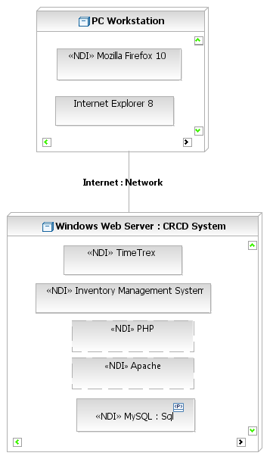

Figure 4: Deployment Diagram

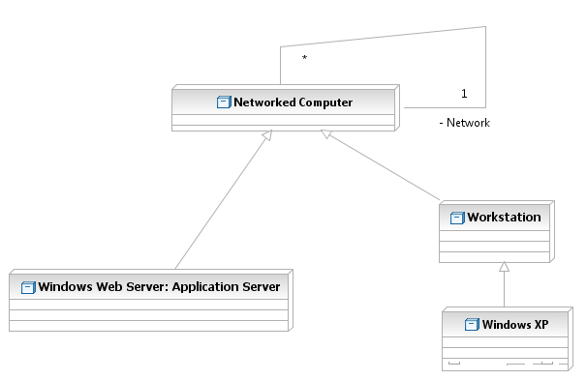
Figure 5: Hardware Components

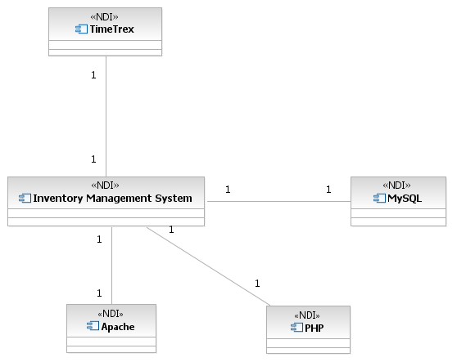
Figure 6: Software Components

Evaluation Summary
We have selected two NDI’s to implement the functionality of CRCD Management system. The TimeTrex system provides basic payroll and attendance services. Timetrex system will be used as the primary system to store all employee information. The Inventory Management System (IMS) provide the inventory management services. IMS also needs employee information for assignment of tasks and inventory items to different employees. To synchronize the shared employee information and provide a single login credential for each employee, the employee information is being centrally stored in TimeTrex database.

IMS database is updated on any transaction that is related to employee or login information through inter-system function calls. So when the user logins to the main system he gets logged in to the IMS system as well. Also the latest employee information is showed in both systems.

This functionality has been tested and verified by the prototype. Since this is the only communication that is needed between the two NDI’s as both NDI’s cater to mutually exclusive requirements, we don’t see any potential interoperability issues arising because of cross-system communication. Other than this both systems have their own exclusive databases and implementations.

